# myLPU AIR-ID: AUGMENTED REALITY APPLICATION USING KANADE-LUCAS-TOMASI (KLT) ALGORITHM FOR LYCEUM OF THE PHILIPPINES UNIVERSITY CAVITE

A Thesis Project

Presented to the Faculty of the

College of Engineering Computer Studies and Architecture

Lyceum of the Philippines University - Cavite

In Partial Fulfillment

of the Requirements for the Degree

Bachelor of Science in Computer Science

**IAN CARLO ROXAS**

**MIGUEL LEDESMA**

**DAVID ISAIAH FRANCISCO**

**MATTHEW ANGELO PURIFICACION**

January 2022

**College of Engineering, Computer Studies and Architecture**

APPROVAL SHEET

This thesis entitled **“****MYLPU AIR-ID: AUGMENTED REALITY APPLICATION USING KANADE-LUCAS-TOMASI (KLT) ALGORITHM FOR LYCEUM OF THE PHILIPPINES UNIVERSITY CAVITE”** prepared and submitted by **IAN CARLO ROXAS, MIGUEL LEDESMA, DAVID ISAIAH FRANCISCO** and **MATTHEW ANGELO PURIFICACION** has been reviewed and recommended as partial fulfillment of the requirements for the degree of Bachelor of Science in Computer Science.

**DR. ELMER C. MATEL**

*Research Professor*

Accepted and approved by the panel of examiners following a successful Oral Defense on [*defense date here*], with a grade of ________.

**MS. AMANDA MENTA, MIT** **MS. JERIAN PEREN**

*Panelist*  *Panelist*

**MR. RENEN PAUL VIADO**

*Panelist*

**DR. ELMER C. MATEL**

*Research Adviser*

**MR. JOVEN B. CAJIGAS, MIT**

*Chairperson*

Accepted and approved in partial fulfillment of the requirements for the degree of Bachelor of Science in Computer Science.

**RAMON C. MANIAGO, PhD**

*Executive Director*

Date: June 24, 2022

# CERTIFICATE OF ORIGINALITY

I/We hereby declare that the research paper entitled:

**myLPU AIR-ID: AUGMENTED REALITY APPLICATION USING KANADE-LUCAS-TOMASI (KLT) ALGORITHM FOR LYCEUM OF THE PHILIPPINES UNIVERSITY CAVITE**

is my/our own work and that, to the best of my/our knowledge and belief, it contains no material previously published or written by another person nor material to which to a substantial extent has been accepted for award of any other degree or diploma of a university or other institute of higher learning, except where due acknowledgment is made in the text.

I/We also declare that the intellectual content of this thesis is the product of my/our work, even though I/we may have received assistance from others on style, presentation, and language expression.

**DAVID ISAIAH FRANCISCO IAN CARLO ROXAS**

*Proponent Proponent*

**MIGUEL LEDESMA MATTHEW ANGELO**

**PURIFICACION**

*Proponent Proponent*

**Date of Completion**: ___________

*(mm/dd/yyyy)*

**Attested by:**

**DR. ELMER C. MATEL**   **Date of Completion:** _________

*Research Professor’s Signature (mm/dd/yyyy)*

# ACKNOWLEDGMENT

The researchers would like to express their gratitude and appreciation to the following people who helped and guided them throughout their research; without them, this undergraduate thesis would not have been possible.

**Mr. Raymund Constante**, their research professor, for his time and dedication in thoroughly checking this manuscript and for guiding and encouraging the researchers to finish and accomplish this study.

**DR. Elmer Matel**, their research professor, for his time and dedication in thoroughly checking this manuscript and for guiding and encouraging the researchers to finish and accomplish this study.

**Ms. Ivy Claire Ong**, Manager of Information and Communication Technology Department, for her helpful, constructive criticism and recommendations that helped the researchers to improve their system.

**Respondents**, for their honest and positive evaluation of the system.

**Parents**, for their overwhelming love and support. Without their guidance and assistance, this study will not be successful.

**MATTHEW ANGELO PURIFICACION**

**DAVID ISAIAH FRANCISCO**

**IAN CARLO ROXAS**

**MIGUEL LEDESMA**

**College of Engineering, Computer Studies, and Architecture**

Bachelor of Science in Computer Science

# ABSTRACT

**MYLPU AIR-ID: AUGMENTED REALITY APPLICATION USING KANADE-LUCAS-TOMASI (KLT) ALGORITHM FOR LYCEUM OF THE PHILIPPINES UNIVERSITY CAVITE**

David Isaiah Francisco1, Miguel Ledesma2, Matthew Angelo Purificacion3, Ian Carlo Roxas4,

Mr. Raymund P. Constante*5*, Dr. Elmer C. Matel*6*

*Proponents 1,2,3,4 Research Adviser 5 and Research Professor 6*

In this paper, the proponents used the AR technology as an extension of information for their school ID, but the challenge of scanning school ID is the wear and tear over usage. This poses a challenge in object recognition and tracking. With the Optical Flow Solution in the KLT algorithm, the proponents tried to solve the object recognition tracking of their current software, the AIR ID.

In this study, the researchers want to contribute new ways for future studies to incorporate AR technology in solving today’s current problems.

Keywords: Augmented Reality, KLT Algorithm, Unity 3D, Vuforia, Firebase

# **TABLE OF CONTENTS**

TITLE PAGE i

CERTIFICATE OF ORIGINALITY iii

ACKNOWLEDGMENT iv

ABSTRACT v

LIST OF TABLES AND FIGURES viii

LIST OF TABLES x

**INTRODUCTION 1**

Background of the study 1

Statement of the Problem 2

Significance of the Study 3

Objectives of the Study 4

Scope and Delimitation of the Study 6

REVIEW OF RELATED LITERATURE AND STUDIES 8

Related Literature 8

Synthesis 12

Related Studies 13

Synthesis 18

Conceptual Framework of the Project 20

THEORETICAL BACKGROUND 22

Fundamental Algorithm Used 22

Definition of Terms 35

DESIGN AND DEVELOPMENT OF THE STUDY 39

System Development Process Model Used 39

Technical Feasibility 42

Software Specifications 42

Hardware Specifications 42

Schedule Feasibility 43

Economic Feasibility 44

Project Design 46

Data and Process Modeling 47

Object Modeling 50

Output and User Interface Design 51

Project Implementation 56

Project Implementation Plan 56

Implementation Procedure 56

Implementation Contingency 56

Duties and Responsibilities 57

Project Testing and Evaluation 57

METHODOLOGY 59

Research Method Used 59

System Development Process Model Used 59

Locale of the Study 65

Respondents of the Study 65

Sample and Sampling Technique 65

Statistical Treatment of Data 66

RESULTS AND DISCUSSION 68

Data Presentation 68

SUMMARY, CONCLUSIONS, AND RECOMMENDATIONS 75

Summary of Findings 75

Conclusions 76

Recommendations 78

# LIST OF FIGURES

**Figure 3‑1**. Object Tracking Flowchart 23

**Figure 3‑2**. Neighborhood W 24

**Figure 3‑3.** Neighborhood W's Features Shown Pixel By Pixel 25

**Figure 3‑4.** Klt Algorithm Flowchart 26

**Figure 3‑5.** System Of Equations In Matrix Form 27

**Figure 3‑6.** Known And Unknown Vectors 28

**Figure 3‑7.** Least Square Solution 29

**Figure 3‑8.** Smooth Regions (Bad) 31

**Figure 3‑9.** Edge Regions (Bad) 32

**Figure 3‑10**. Texture Regions (Good) 33

**Figure 3‑11.** Tracked Feature Points 34

**Figure 4‑1**. Agile Software Development 39

**Figure 4‑2**. System Compatibility Of Mylpu Air-Id 42

**Figure 4‑3**. Mylpu Air-Id Gantt Chart 43

**Figure 4‑4.** Requirement Modelling Of Mylpu Air-Id 46

**Figure 4‑5**. Flowchart Of Kanade-Lucas-Tomasi Algorithm 47

**Figure 4‑6**. Flowchart For Login 48

**Figure 4‑7.** Flowchart Of The Application Usage 49

**Figure 4‑8.** Use Case Diagram Of Mylpu Air-Id 50

**Figure 4‑9.** Application Icon 51

**Figure 4‑10.** Home Screen 52

**Figure 4‑11.** General Augmented Screen 53

**Figure 4‑12.** Schedule Screen 54

**Figure 4‑13**. Edit Information Screen 55

**Figure 5‑1.** Agile Software Development 59

**Figure 5‑2**. First Prototype Design Of The System 61

**Figure 5‑3.** First Working Prototype Of The Home Screen 62

**Figure 5‑4.** Working Prototype Of The General Augmented Screen 62

**Figure 5‑5**. Working Prototype Of The Schedule Screen 63

**Figure 5‑6.** Evaluation Of The System With It Experts 64

**Figure 5‑7.** Demonstration Of The System 64

# LIST OF TABLES

**Table 4‑1.** Cost Benefit Analysis 45

**Table 5‑1.** Air-Id Requirements 60

**Table 5‑2.** Numerical Rating And Its Corresponding Equivalent 66

**Table 5‑3.** Likert Scale 67

**Table 6‑1**. Functional Testing Result 68

**Table 6‑2.** Summary Of End User's Evaluation By Mars 69

**Table 6‑3.** Summary Of It Expert's Evaluation By Mars 70

**Table 6‑4.** Summary Of End Users And It Expert's Evaluation By Mars 71

**Chapter I**

## **INTRODUCTION**

## **Background of the study**

According to Carmigniani & Furht (2011), the first emergence of Augmented Reality (AR) dates back to the 1950s, when a cinematographer named Morton Heilig thought that cinema should be able to draw the viewer into the onscreen activity. Then Heilig built a prototype called Sensorama, which he described as “The Cinema of the Future” in 1955, which predated digital computing.

The use of Augmented Reality in Mobile devices has evolved over the past years between 1968 and 2014, as well as the meaning of Mobile Augmented Reality. The first development of Mobile AR was made as a wearable AR that lets you experience Augmented Reality while moving (Arth et al., 2015). With the evolution and miniaturization of technologies, the concept of mobile AR evolved into mobile devices and even plain objects if the sensor can detect the pattern or subject.Tracking points ("features") across multiple images is a fundamental operation in many computer vision applications.

This work aims to show computer vision's (CV) capability for estimating the dynamic characteristics of two mechanical systems using a noncontact, markerless, and simultaneous single input multiple output analysis. Kanade–Lucas–Tomasi trackers are used as virtual sensors on mechanical systems' video from a high-speed camera (Yongyong et al., 2020). Augmented Reality has been around for some time now, but camera phones in and below the "mid-range" segment are not equipped with cameras good enough for AR applications. Most school people use phones in the "mid-range" segment.

## The existing methods are not suitable to be applied directly in the mobile AR system for the built environment due to poor real-time performance and robustness (Wu et al., 2021). Using the KLT Algorithm, the researchers can improve the tracking and recognition of objects seen by the AR application more efficiently.

## **Statement of the Problem**

University students face specific issues that cause them to delay or miss some of their classes. With all the projects, quizzes, exams, deadlines, and college fees that they need to worry about, getting information about the university's different college buildings and rooms is not the most important thing on their mind. The same goes for school-related information such as links, schedules, and other details that students might use on campus. New students especially face this problem whenever they enroll in a new university. They tend to have trouble locating their classes, laboratories, and school office locations. Now, when a student forgets a single piece of information, where is the best place to check it? Yes, using a smartphone.

Students don't often use their ID anymore since its information is too limited. With the system "myLPU AIR-ID: Augmented Reality Application Using Kanade-Lucas-Tomasi (KLT) Algorithm for Lyceum of The Philippines University Cavite," the students will be given and provided with more available information and resources such as their student number, class schedule, and school-related links which can be accessed through their smartphones.

By default, the AIR ID application uses the regular camera setting when deployed using Unity 3D and Vuforia. This implies that the application depends only on the camera specs and ability. Some students might also have issues regarding their IDs, like fading and the readability of certain features on their ID. This part is where the Kanade-Lucas-Tomasi (KLT) Algorithm comes in. With the implementation of the KLT Algorithm, the camera and visual performance of the application will vastly improve compared to the default implementation using Vuforia and Unity. It also solves the problem of the readability of specific IDs and the shaky camera movement.

## **Significance of the Study**

The research project myLPU AIR-ID: Augmented Reality Application using Kanade-Lucas-Tomasi (KLT) Algorithm for Lyceum of the Philippines University Cavite would benefit the following:

**Students of Lyceum of the Philippines University Cavite.** The software will provide immediate information to students who want to know about their student-related information, such as class schedules, school-related links, and more. The Kanade-Lucas-Tomasi Tracker or KLT algorithm will ensure that the system will locate and recognize the trackable features of the ID.

**LPU Management.** The software will help the management by making sure that the students will not forget to bring their IDs to the University since the software will provide more useful functions to the ID that the students can use. Because of this, there will be less work to do for the management specially for the security and SAO department.

**The proponents.** This project is helpful to the proponents’ growth and improvement of their skills in applying an algorithm and making an application that uses the database and Augmented Reality system. By doing this project, the researchers will gain more knowledge and experience that might be helpful in the future.

**Future researchers.** This can be helpful for future researchers who would like to study the same field and technology by making the project their guide to creating a project with similar features, especially since there aren’t a lot of AR Technology projects yet. Here, the contents might help future researchers find a way to use the mentioned technologies in this study.

**Objectives of the Study**

The proposed project aims to develop "my AIR-ID: Augmented Reality Application using Kanade-Lucas-Tomasi (KLT) Algorithm for Lyceum of the Philippines University Cavite." This study aims to implement an algorithm that can help the system scan and track the image target better and faster. With the help of the proposed algorithm, the smartphone's camera can focus and follow the image target, which is the school ID, precisely, resulting in faster image recognition and smoother movement of the AR graphics.

Specifically, it aims to:

1. Design an AR application with the following features:
   * + 1. A startup screen that lets the user scan their ID to log-in to the system.
       2. Display the student’s information: full name, student number, course, and schedule of the student’s subjects.
       3. Display buttons for the AIMS website, myLPU mrooms, and LPU Cavite Facebook page that will redirect you to the specific website when you click on the corresponding button.
       4. Store data using the school ID of the user as the Target Image to display the AR Scenes.
2. Create a system using Unity3D and Vuforia as the application for developing the frontend while using C# language for the backend. It will run on android devices compatible with Google AR Core.
3. Create a log-in at the beginning with the help of Firebase.
4. Optimize the system with Kanade-Lucas-Tomasi Tracker (KLT) algorithm to ensure that the system can recognize and locate the trackable features of the ID efficiently.
5. Test and improve the system using functionality tests and compatibility tests.
6. Evaluate the quality of the system using the Mobile Application Rating Scale (MARS) with the following criteria
   1. engagement.
   2. functionality.
   3. aesthetics.
   4. information; and
   5. subjective quality.

## **Scope and Delimitation of the Study**

This project's scope is to provide students with quick access to school-related information. With the use of Augmented Reality, the students can view more information located on their ID. Not only will their name and student number be considered, but also their class schedule, subjects, and school-related links (LPU Cavite Facebook page, Moodle mrooms, AIMS) with the help of the AIR-ID Mobile Application. The user will need to scan their ID through the AIR-ID App to display the information linked to their ID. With Unity and Vuforia, developers could create, design, and implement visual elements that will appear on the screen when the ID is scanned using the phone camera. These graphic elements will display the information related to the owner of the student ID. The visual elements are created using Unity and Vuforia sdk. The sample photo of the student ID card is uploaded to the database as image targets so Vuforia will recognize the information to display on the phone. By using Kanade-Lucas-Tomasi (KLT) Algorithm, the system will be more optimized at locating and identifying the trackable features of the students' ID.

The project will not extend to interactive AR because it will complicate the task and may require lots of time (based on our skills and experience). The project limits its coverage to the students currently enrolled in the university. As of now, the application won’t be available to apple devices. The application is intended to be used on android devices compatible with google AR Core.

**CHAPTER II**

# REVIEW OF RELATED LITERATURE AND STUDIES

This chapter covers all the related literature we have read, aligned with our interest in the possibilities of applying Augmented Reality technology to solve a specific problem, specifically, some terms are listed below that define our research.

## **Related Literature**

It is a detailed review of literature or research that is related to the topic of this thesis. For instance, the materials are mostly from professional journals and other publications. Composed here are the keywords related to our project. Some are cited from the documentation of the mentioned keywords, and some are from respectable and reliable websites.

**Augmented Reality**

Augmented Reality (AR) is an improved form of the physical world that's accomplished by utilizing computerized visual components, sound, or other tangible boosts conveyed via technology (Hayes Adam, 2020). It may be a trend among companies included in versatile computing and trade applications. Augmented Reality calculates the camera's distance, position, and angle in real-time and places the corresponding image in the computed position (Tom Caudell, 1990).

Augmented Reality can also be utilized for other tasks, such as enhanced collaborative tasks. One of the examples of this is the Studiers tube project of Schmalsteig et al., 1996). They used a head-mounted display glass that resembles a VR Box connected to the system, allowing users to see the 3d models and images together. It is similar to the researcher's study, but the intended hardware is the mobile phone instead of a head-mounted display.

According to Papagiannis (2009), AR has advanced, and many restrictions have been resolved. New opportunities and ideas have been unlocked with the help of augmented reality in learning applications and art implementations that can expand the user’s creativeness. AR projects are primarily utilized in 3d models and animation. Still, it can also be used in 2d planar videos and others that can be applied in novel forms and hybrid physical-augmented applications.

**AIR-ID**

The AIR-ID aims to provide more information about the school and the student course using augmented reality technology. Augmented Reality (AR) is the technology of adding virtual objects to real scenes by enabling the addition of missing information in real life (E. Sayed, 2011)

AIR-ID includes the user’s name, section, school ID number, schedule, and corresponding buttons that will redirect the user to the websites (LPU Cavite Facebook Page, LPU rooms, and LPU aims) when pressed the corresponding buttons.

**Unity 3D**

According to Lebo et al. (2010), Unity3D is an integrated professional game engine made by the Danish Unity Technologies. Which can create 2D and 3D video games, virtual constructions, and various real-time 3D images and models. The researchers mainly used Unity3D in developing floating AR images.

**Vuforia**

Vuforia Engine is a software development kit (SDK) for creating Augmented Reality apps. Aji et al. (2018) used Vuforia in their AR system to emphasize the 3D marker-less recognition process in their virtual exhibition project. In this project, the researchers will use Vuforia to add advanced computer vision functionality to the application.

**C# (C Sharp)**

According to Tiara Dewi and Muhammad Amir Masruhim (2016), C# is an object-oriented and type-safe programming language. C# also provides language constructs, making it a natural language used to create and use software components. The researchers will use C# as the primary programming language in their research.

**Kanade-Lucas-Tomasi Algorithm**

Kanade-Lucas Tomasi or KLT Algorithm is used for feature selection and tracking objects. Mstafa & Elleithy, (2016). The KLT tracking algorithm operates by finding good feature points or what they call Harris Corners in the facial area from the first frame.

The algorithm locates the trackable features in the initial frame and then tracks each detected quality in the rest of the structures using its displacement. The displacement of the specific part is then defined as the displacement that minimizes the sum of differences. Sri (2019).

**Firebase**

According to Stevenson (2018), firebase is a toolset to build, improve and enhance your application. Firebase helps the developer cover many services that the developers would typically code and build themselves. Such as authenticators, databases, push messaging, file storage, etc.

Firebase Realtime Database and Firebase Authentication are used in programs to collect and secure the data and application. The Firebase Realtime database displays data in JSON format. According to Rajappa et al. (2020), one of the advantages of using it is that the data is synchronized across all clients in real-time and is even available even when the application doesn’t have access to the internet.

**JSON File**

JSON or JavaScript Object Notation is a minimal, readable format for structuring data. It is commonly used to transmit data between the server and an application. According to Chris (2021), JSON and objects aren’t the same. The main difference is that the key in JSON must be on double quotations or “ “ and the values apart from the number and invalid types must be in double quotes too.

JSON can be defined as either object or an array with several objects. So automatically, both arrays and objects are acceptable data types in JSON. It also supports Boolean, null, and string.

**Synthesis**

All the cited literature listed here by the proponents is related to the project's conceptualization and will serve as the guide throughout the study.

Based on the research the proponents conducted, Augmented Reality is the only option for adding visuals that interact with the real world. Virtual Reality can't do what we desire because VR is focused on immersing a consciousness using a simulated 3D environment. In contrast, Augmented Reality directly taps into the real-world scenes through the lens of a smartphone camera or other AR-enabled devices.

After reading and comparing different applications, the researchers have concluded that Unity 3D and Vuforia are the most suitable software for developing Augmented Reality applications. Each software is straightforward to understand and utilize. Unity 3D is the most suitable software for creating our project.

## **Related Studies**

Composed of reviewed existing studies conducted to which the proposed research is related. These are local and foreign studies cited by the researchers relevant to their research. A work that was concluded after a thorough experiment or investigation is considered a study. They are usually Books, theses, dissertations, research projects, and research papers. Listed below are the related studies with similarities and correlations to the research project.

**Image stabilization algorithm based on KLT motion tracking**

According to Yongyong et al. (2020), the first step in image stabilization is to estimate the motion according to the video image sequence, obtain the global motion parameters, and then carry out the motion compensation. After the comprehensive evaluation, a stable output sequence can be obtained.

Currently, the accuracy of the electronic image stabilization algorithm, the range of displacement of the algorithm, and the characteristics of the image stabilization system are usually used as the performance indexes of various algorithms. The algorithm's accuracy is to evaluate the stability of the image after compensating for the amount of vibration of the camera. It mainly includes MSE and Peak Signal Noise Ratio.

They implemented upgraded high-performance encryption based on AES, simulated and verified by ModelSim Simulator. The model of encryption and decryption is implemented based on their iteration loop that has both round and inverse round transformation.

**Accessibility of mobile devices**

According to Turner (n.d.), there are currently 6.378 billion people in the world that use a smartphone, meaning that 80.69% of the world owns a smartphone. With the help of statistics, they also predicted that substantial growth for all smartphone users would increase from a 6.378billion to 7.516 billion.

The Philippines, on the other hand, as of 2020, has 41.31 million people that use a smartphone; out of 109.58 million people in the country, there are 37.70% of people that owns a smartphone. With this amount of people owning smartphones, the implementation of the project is more possible and feasible.

**On Computer Vision for Augmented Reality**

Computer Vision is an excellent use for various Augmented Reality Applications. It can rely on visual features such as patterns that the camera can scan. (Lepetit, 2008). With the help of computer vision, the AR Application can detect the right size and position on where they will display the generated model or images. Suppose an AR Application doesn’t use Computer Vision for positioning. In that case, the user must manually resize and set the model or image’s position. In contrast, an AR Application with computer vision will automatically position the object on the screen.

Computer vision for augmented reality lets the application and the computer obtain, detect, and understand images and objects. By scanning the surrounding objects and ideas, the program can detect image targets to display the visuals on the AR Camera. Zharovskikh (2020).

**The use of Unity3D and Vuforia**

According to Karkera et al. (2018), Unity3D and the Vuforia plug-in are very helpful in developing Augmented Reality (AR) applications. They can create several applications with the help of the Augmented Reality concept. They also said that it could be used for marketing products where there will be a marker stitched or stuck on a particular product which then can be scanned, showing all the available information about the said product. Unity 3D allows rapid application validation and prototyping. It also has compatibility with various 3D files and scripting features, along with its availability for cross-platform (Bedoya-Rodriguez et al., 2015). Vuforia Software Development Kit (SDK) is software development equipment mainly used for mobile devices by Qualcomm to create Augmented Reality (AR) applications. Vuforia SDK supports 2D and 3D objects, including multiple target configurations and images with frame tags and symbols (Koca et al., 2019). This type of system or application will be implemented to create the project the researchers are making.

**ARSC Augmented Reality Student Card**

According to N. A. M. El Sayed et al. (2010), Augmented Reality is the technology of adding virtual objects to natural scenes by enabling the addition of missing information in real life. They used AR Technology to create a student card with a static marker in cards that will display different objects depending on the assigned card. This research titled “my AR-ID: Augmented Reality Application using Kanade-Lucas-Tomasi Algorithm for Lyceum of the Philippines University Cavite” is somewhat similar to this Research study since both used Augmented Reality Technology to improve the overall experience of the students.

**Snapping 3D Objects in Augmented Reality**

According to Do & Lee (2009). Many Augmented Reality Systems have been developed in various fields. Most of those systems are running in real-time so that the users can interact with them. Snapping 2D objects is not that hard since most vector-based applications have this feature. While photographing in 3D is more challenging since it has one more dimension you need to consider.

In Do & Lee’s Research, they used an algorithm for snapping multiple 3D objects together. At the same time, in this research project, the researchers intended to photograph the 3D objects and table to the School ID so that it will move along with the ID if the user tries to rotate and adjust their school ID while looking through their phone.

The algorithm they used is also designed to deal with primitive geometries such as cubes, cones, cylinders, and spheres. The main idea of the algorithm is that each kind of geometry is defined, and if the center point of the target image is moved within the hotspot, any existing geometry will be snapped to it.

**Image targets in Vuforia**

Fuguo & Zhai (2017) state that Vuforia utilizes computer vision technology to track and recognize simple 3D objects and graphic images in real-time. Vuforia also provides developers with directed and positioning virtual capability. Augmented Reality applications based on the Vuforia SDK use the screen of mobile devices as the hub to connect the real world to the AR world. Images previewed in the device's camera are rendered by applications and will be displayed on the device for it to turn into real photos. It gives people a sense of immersion by adding virtual 3D objects to natural images.

The Vuforia SDK provides a good user experience because of these aspects:

1) Better and faster speed of local target recognition.

2) The use and support of the technology that recognizes millions of targets.

3) Highly robust target tracking that won't be easily affected by mobile devices;

4) Support and recognition of partially covered and low-light targets.

**Algorithm Improvement for Augmented Reality based on the Natural Features**

Image matching is essential in many applications specially in Augmented Reality and search engine applications (Yang et al., 2012). It is used in object and image recognition, motion tracking and object snapping. This technology has very wide application prospect and is suitable for most AR application projects.

**Target Recognition Technology**

According to Fuguo & Zhai, (2017) target detection and recognition is used in order to understand the real scene and to figure out the target in the scene. They also said that target recognition can be divided into two kinds of AR field:

1) From the perspective of categorization and detection.

2) From the perspective of image matching.

In the field from the perspective of categorization and detection, machine learning algorithm is used in order to acquire characteristics of certain categories and to generate the data model. While from the perspective of image matching, the database will preserve the features of the image and its corresponding information.

Ding et al.(2017), also said that target recognition has been a challenging task in SAR image interpretation and to avoid using the high-dimensional images for recognition, the feature extraction was used as one of the key steps in the program, it is applied to target recognition by the help of edge and region movement and others.

**Application of Firebase web application**

As stated in the study of Khawas & Shah (2018), Firebase is a relatively new technology compared to other database management systems like Oracle SQL, Microsoft SQL Server, and MySQL but proven to be faster and better, especially with managing large amounts of unstructured data such as audio, video, text files, and other arbitrary file types. For beginners, Firebase is the best option for database and other backend-related work so developers can focus better on application programming instead of allotting lots of time to backend programming.

**Synthesis**

The various studies cited here are mostly related to the creation and conceptualizing of the project that will serve as a guide and basis for the study. Based on the comparison with this research and other researchers’ studies, the researchers found out that various studies have similarities with this research and can use those data to improve further the software application, such as the use of Computer Vision for automated object positioning (Lepetit, 2008).

The papers “Pokemon Fight Augmented Reality Game,” “Augmented Reality RPG Card-based Game,” and “Augmented Reality Application for Preschool Children with Unity 3D Platform” discussed why Unity 3D and Vuforia are the best options for applications to use when developing an Augmented Reality (AR) application. It expounded on how and why these two applications are considered the best whenever one is making an AR application, which is why the researchers decided to use this application for their project.

## **Conceptual Framework of the Project**

Requirement Planning between researchers lead to initializing what are the fundamental requirements on creating “myLPU AIR-ID: Augmented Reality Application Using Kanade-Lucas-Tomasi Algorithm for Lyceum of the Philippines University Cavite", Each individual member should have background knowledge of each stated related literature. The details in Figure 2-1 provides an overview of this information.

**INPUT PROCESS OUTPUT**

**Figure 2‑1.** Conceptual Framework of the Proposed Project

**Knowledge Requirement**

* C#
* Augmented Reality
* KLT Algorithm

**Software Requirement**

1. Visual Studio
2. Windows OS
3. Unity 3D
4. Vuforia
5. Android OS

**Hardware Requirement**

1. Laptop / PC
2. 16 GB RAM

Recommended while minimum is 8GB

1. 4 GB hard disk space

b. Android Phone

1. ARCore supported
2. 4GB RAM Recommended while minimum is 2GB
3. Estimated 200MB

**Rapid Application Development Methodology**

* Requirement Planning
* User Design
* Refine
* Prototype
* Test
* Construction / Development
* Cutover

**myLPU AIR-ID: Augmented Reality Application using KLT Algorithm for Lyceum of the Philippines University Cavite**

**EVALUATION**

MARS

Rapid Application Development is the researcher's chosen methodology since RAD has quicker adjustments. AIR-ID updates its data precisely on the student's schedule every semester. RAD is an Agile software development strategy that encourages and adjusts quickly during development. RAD also has lower development costs because the development time is less. If the researchers want to make changes, they won't need to start the project all over again from the beginning, leading to less cost overrun.

The complete system will be called "my AIR-ID." We played with the word AIR and Augmented Reality (AR). The researchers used AIR because the Data that is being shown by the application looks like it is floating in the air with the help of Augmented Reality Technology.

**CHAPTER III**

# THEORETICAL BACKGROUND

## **Fundamental Algorithm Used**

**KLT Algorithm**

The Kanade-Lucas-Tomasi (KLT) algorithm is based on an early project by Bruce D. Lucas and Takeo Kanade in 1981 with the title "An Iterative Image Registration Technique with an Application to Stereo Vision", on this paper they presented a new image registration technique which uses spatial intensity gradient information to direct the search for the position that yields the best match (Bruce, 1981). Then it was fully developed and improved by Carlo Tomasi and Takeo Kanade in April of 1991 with the title "Detection and Tracking of Point Features," where they focused on a method for choosing the best feature or image patch for tracking (Guru & Dinesh, 2004). Later it was clearly explained by Jianbo Shi and Carlo Tomasi in the paper titled "Good Features to Track" (Shi, 1994).

**Object Tracking**

Object Tracking is the application of deep learning. The program registers and scans an object and develops a unique identification for each scan that it detects and then tracks the registered objects as they move around frames in a video Meel. (2021). Object tracking is also about locking onto a particular moving object in real-time. Object tracking involves many parts, such as:

Motion Detection - it is mostly used in surveillance systems such as security CCTV.

1. Object Localization – it focuses on data reduction and region of interest in an image.
2. Motion Segmentation – images are segmented into region corresponding to different moving objects.
3. Object tracking – a set of features is often tracked.

**Proposed Method**

The purpose of the object tracking and detection in the system is mainly divided in three parts. First, to detect an image to be used on tracking (School ID). Second, identify specific features from the image to track. And lastly, track the complete image using the specific features. Refer to Figure 3-1for the flowchart of the tracking process.

**Figure 3‑1**. Object Tracking Flowchart

In figure 3-2, a certain region called Neighborhood is selected within an image or video designated with the letter *W*.

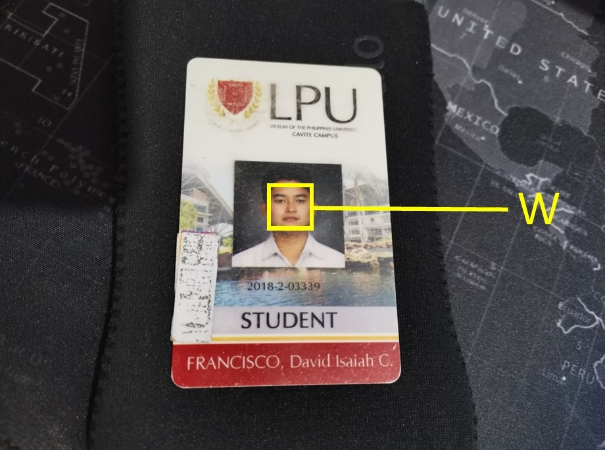

**Figure 3‑2**. Neighborhood W

In figure 3-3, the selected pixels are shown within the neighborhood. Every pixel’s color intensity is compared with each other. Every pixel is computed based on the Optical flow method of KLT Algorithm.

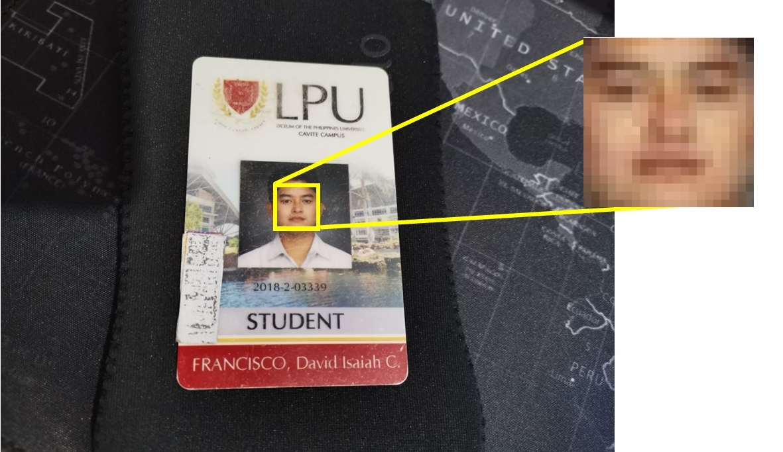

**Figure 3‑3.** Neighborhood W's Features shown pixel by pixel

When a good feature is located, it is extracted from the image or video then is passed on to an array for storing. Every feature extracted and stored are classified as “*good features*”. Next time the same image target is present on video capture, the algorithm will find all the matched features then will be compared to the detected object on video capture.

**KLT FEATURE TRACKING**

The KLT algorithm tracks an object in two steps, first it locates all the trackable features in the initial frame, then it will track each one of the detected features in the rest of the frames by means of its displacement. After getting the displacement of the specific feature it then will be defined as the displacement that will minimize the sum of differences.

**Figure 3‑4.** KLT Algorithm Flowchart

When an image target is captured (implying that the target’s features are already saved), the algorithm will search for all saved features and identify the detected object in video capture. When a feature matched, the algorithm will now focus on tracking the detected object until the system is stopped or the image target is out of vision.

**Mathematical Model/Formula Used.**

The optical flow estimation assumes that all pixel intensities in segment *W* are converted from one frame to another. (Fleet & Weiss, n.d.). Here in *equation (1)* the formula contains the derivative of intensity in the X direction times u plus the derivative of intensity in the Y direction times v plus the derivative in time of direction equals to zero.

|  |  |
| --- | --- |
| For all points (*k, l*) ∈ *W*: $$I_{x}\left(k, l\right)u+I_{y}\left(k, l\right)v+I_{t}\left(k, l\right)=0$$ | (1) |

The point (*k, l*) has constraints but since there are many points within a segment, the formula will end up on a system of equations. The Fig 3-5 shows how the number of equations will be equal to the number of pixels inside the segment *W*.

Let the size of window *W* be $n×n$

In matrix form:

**Figure 3‑5.** System of equations in matrix form

These are the equations and can be written stacked up in matrix form.

Shown in Fig 3-6, the matrix consists of two known vectors, A and B, and the unknown vector $u$, that is what the algorithm is trying to find for the segment *W*. That is the optical flow. The problem of n squared equations and unknowns u and v is solved using the Least Square Solution. (2) (3)

**Figure 3‑6.** Known and Unknown Vectors

**Least Square Solution**

Solve linear system:

$Au=$*B* (2)

Least Squares using pseudo-inverse:

$A^{T}Au=A^{T} B$ (3)

Solution will be $u={\left(A^{T}A\right)}^{-1} A^{T} B$ (4)

**NOTE**: *A* transpose *A* is a 2 × 2 matrix.

In Fig 3-7, the elements within the transposing are all spatial derivatives. Spatial derivatives are the rate of change of a given scalar physical quantity with respect to the position coordinates.

**Figure 3‑7.** Least Square Solution

**When does this solution not work?**

The whole equation will not work if the $A^{T}A$ is not invertible and not well conditioned. If λ1 and λ2 are eigen values of *AT A*, then.

λ1 > ∈ and λ2 > ∈ (5)

λ1 ≥ λ2 but not λ1 >>> λ2 (6)

On the first iteration (5), Eigen values 1 and 2 are significant enough. Neither one is close to zero. It can also be lambda one is greater than two and vice versa, which will often happen. But one cannot be significantly larger than the other one (6). To further explain how this works, here are sample visuals to see how these manifests in real images.

Here in figure 3-8 shows lambdas 1 and 2 are both small. Meaning, the equations for all pixels are more or less the same because the segment does not contain any texture. The spatial gradients are not reliably computed. The ellipse at the middle of the graph shows how both eigen values are close to zero. This is the same concept as human vision, if all gradients are the same, human vision cannot tell if the object is moving or not, hence, unreliable optical flow.

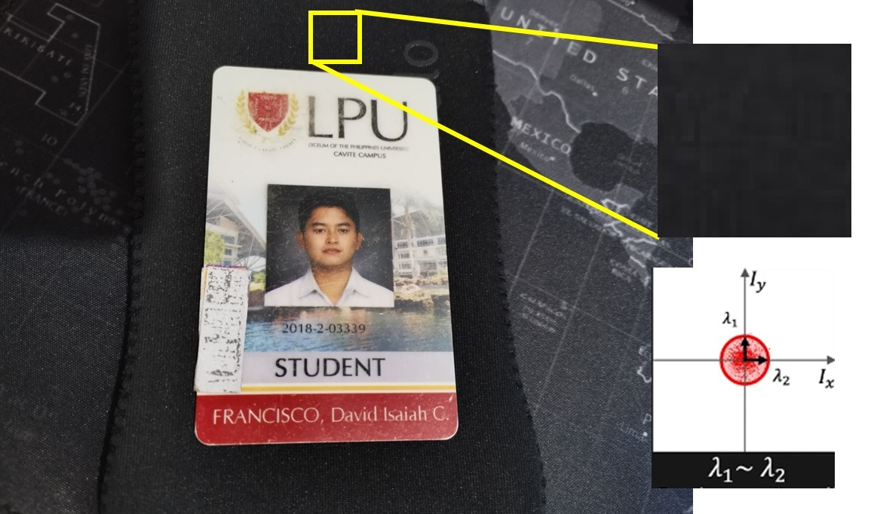

**Figure 3‑8.** Smooth Regions (Bad)

In figure 3-9 shows how the ellipse is greatly stretched throughout the graph. This manifests how the lambda one is greater than lambda two. Segments containing prominent gradients are also considered badly conditioned segment. The problem with prominent gradients is it is hard to tell if the edge actually moves from one direction to another and how fast it moves.

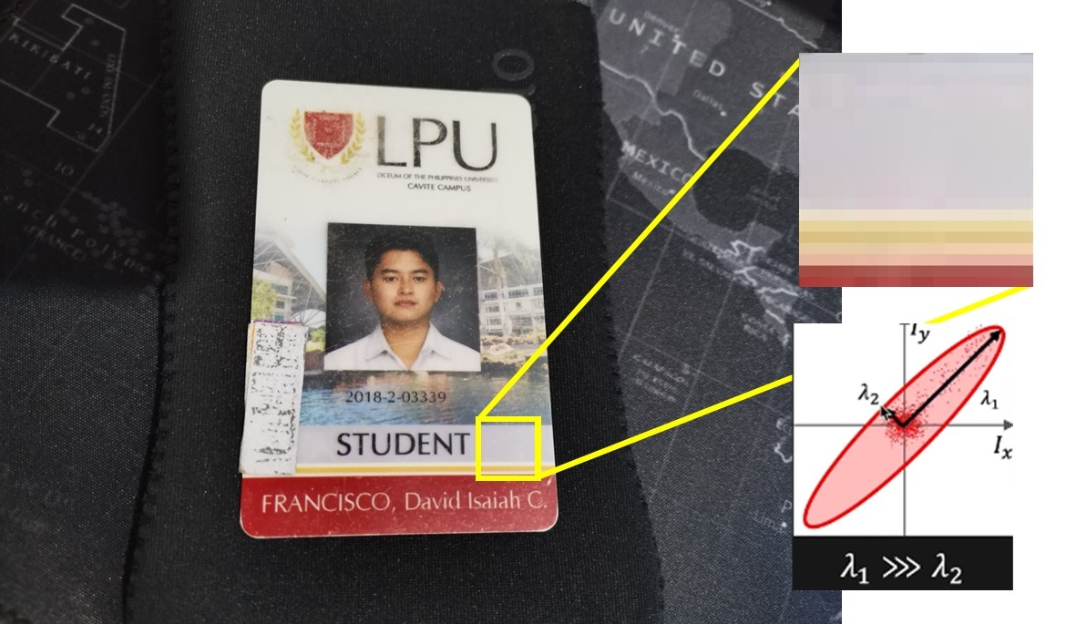

**Figure 3‑9.** Edge regions (Bad)

Here in figure 3-10 shows how the segment is texture rich and has diverse gradient magnitude. The optical flow can be reliably computed if a lot of different values in brightness on both directions are detected. The graph shows how both lambdas are significant enough for the equation because the gradients are scattered across the segment.

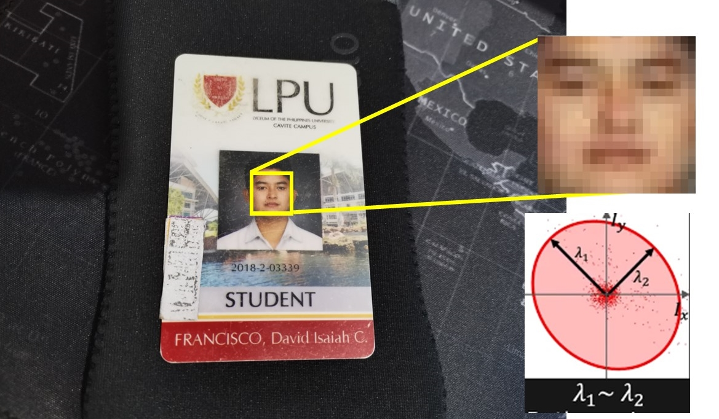

**Figure 3‑10**. Texture regions (Good)

**Results**

Here in Figure 3-11, the points of features extracted are tracked when on vision. The figure also indicates how the absence of optical flow in smooth and edge regions are not detected. Only the texture rich regions are selected.

**Figure 3‑11.** Tracked Feature Points

## **Definition of Terms**

**KLT Algorithm** Kanade-Lucas-Tomasi (KLT) Algorithm is used by the researchers to improve the tracking and recognition capabilities of the AR Camera used by the Application.

**Algorithm** Algorithm is a series of instructions telling a computer how to act and transform a setof instructions into a useful information. In mathematics and computer science, an algorithm usually means a small procedure that solves a recurrent problem.

**Augmented Reality** Augmented Reality Enhanced version of the real physical world achieved using digital visual elements delivered via technology.

**C#** C# is an object-oriented programming language that aims to combine the computing power of C++ and the programming ease of Visual basic. It is the main Language used by the Researchers on creating the System.

**Computer Vision** Computer vision is a field of artificial intelligence that trains computers to interpret and understand the visual world. Using digital images from cameras and videos and deep learning models, machines can accurately identify and classify objects and then react to what they see. The researchers use an algorithm that is classified as computer vision to detect feature points in the student IDs so that the application can recognize the target image.

**Firebase** Firebase is a toolset to build, improve, and grow an application. It gives the researchers a large portion of services that the developers would normally have to build themselves such as database, authentication, configuration, push messaging etc.

**Harris Corner Detector** Harris Corner Detector is a corner detection operator that is commonly used in computer vision algorithms to extract corners and infer features of an image.

**Image Stabilization** Image Stabilization is a family of techniques that reduce blurring associated with the motion of a camera or other imaging device during exposure.

**Image Target** Image target is the object that represent the images that the Vuforia engine can detect and track. The engine detects and tracks the image by comparing extracted natural features from the camera image against a known target resource database. Once the image target is detected, Vuforia Engine will track the image and augment your content seamlessly using best in market image tracking technology.

**Image Tracking** Image tracking detects two-dimensional planar images from a custom-defined target set, and then continuously tracks the images’ locations and orientations as you or they move in the setting. Image tracking is used by the system so that the AR graphics generated by the system could follow the Target image (School ID) even if the user moves it around the camera.

**JSON** JavaScript Object Notation or JSON is a text-based human-readable data interchange format used for representing simple data structures and objects in web browser-based code. It is also sometimes used in desktop and server-side programming environments.

**Motion Segmentation** Motion segmentation is the task of identifying the independently moving objects in the video and separating them from the background motion.

**Motion Tracking** Motion tracking assists in tracking the movement of objects and transferring the sensed data to an application for further processing. It is used to track the Student ID so that the AR graphics can follow the ID if the user moves it around the camera.

**Object Localization** Object localization refers to identifying the location of one or more objects in an image and drawing abounding box around their extent. It combines these two tasks and localizes and classifies one or more objects in an image.

**Point Tracker**  The point tracker object tracks a set of points using the KLT, feature-tracking algorithm. It is often used for short-term tracking as part of a large tracking framework.

**Prefab** Prefabs are a special type of component that allows fully configured GameObjects to be saved in the project fo reuse. These assets can then be shared between scenes, or even other projects without having to be configured again.

**RAD Methodology** Rapid Application Development or RAD is an agile project management strategy popular in software development. It is a more adaptive approach to software development. While regular plan-based methods require a rigid structure with specific requirements, a RAD approach is based around flexibility and the ability to adapt alongside new knowledge.

**Tracking Algorithm** Tracking algorithm is a radar and sonar performance enhancement strategy that provides the ability to predict future position of moving objects.

**Unity** Unity is a cross-platform game engine developed by Unity Technologies which can create 2D and 3D video games, virtual constructions and various real time 3D images and models.

**Vuforia** Vuforia is anAugmented Reality software development kit for mobile devices that enhances the creation of augmented reality applications. It uses computer vision technology to recognize and track planar images and 3D objects in real time.

**CHAPTER IV**

# DESIGN AND DEVELOPMENT OF THE STUDY

## **System Development Process Model Used**

The proponents used Agile Methodology in developing their system. The Agile Software Development Methodology is considered one of the most meaningful and straightforward ways to manage a project because it breaks the project into several stages. The software product will be broken down into small incremental builds in iterations in an Agile Software Development Life Cycle. The product will go through different iterations and will be continually tested and given feedback to create more iterations. When the product passes through an iteration, the software has been enhanced and improved. The product will repeat the cycle until all the specific software functionalities are met.Diagram

**Figure 4‑1**. Agile Software Development

The proponents decided to follow the Agile Methodology because of its ability to quickly adapt to changes and ensure that the software requirements and functionalities will meet the aimed quality of the product. With the help of Agile Methodology, the system's features' improvement and implementation will be much easier because all the functions and features of the software will be checked in-depth with each iteration. also, another benefit of this is that all the bugs and errors can be detected and remedied much earlier. Ensured customer satisfaction is also another reason why the proponents chose Agile Methodology. With Agile Methodology, the client is always involved in the development. With this, the proponents can easily tend and make changes to the system according to the feedback and needs of the client to ensure that the system will genuinely meet their requirements. The following are the steps for Agile Development:

1. Requirements

For the first stage of the Agile Software Development Cycle, the proponents need to define the requirements needed for their project.

1. Design

On this stage the proponents need to design and start to develop their project with the requirements that they planned.

1. Development

On this stage the proponents should start developing a prototype of their project. This stage is where the iteration happens, remedies and revisions will occur until the goal is satisfied for the last iteration.

1. Testing

On this stage the system should have complete documentation of the results and a thorough testing of the system.

1. Deployment

On this stage the project should be properly working and should be ready to present to the clients.

1. Review

On this final stage the proponents should get the feedback from their clients and gather the information about what they think about their project and work on improving it.

## **Technical Feasibility**

Figure 4-2 represents the compatibility of myLPU AIR-ID in terms of devices and operating systems to be used. This shows that the developed system can operate on Android devices with the Android Operating System.

**Figure 4‑2**. System Compatibility of myLPU AIR-ID

## **Software Specifications**

Unity and Visual Studio 2019 is used in developing the system and C# is used as the main programming language. Software development kits are also used by the proponents for implementing and designing the visual elements of the system, such as Firebase for the login screen, and Vuforia for the AR function.

## **Hardware Specifications**

The proposed system can run on android devices which has Android Marshmallow (Android 6.0) and up. The device must have a minimum of 4GB RAM, and at least 32GB of memory. The system can work and scan the target up to 4 to 5 feet with a 48 Megapixel Camera, while it can scan up to 10 feet with a 108 Megapixel based off the proponent’s observation.

## **Schedule Feasibility**

Figure 4-3 shows the system Gantt Chart of myLPU AIR-ID which specifies how the activities are done and shows the period when the production is completed.

**Figure 4‑3**. myLPU AIR-ID Gantt Chart

The Gantt Chart records the time and duration of the processes that the researchers have conducted from August 2021 up to June 2022. The first activity that the researchers conducted was brainstorming, in which they shared ideas for possible titles so that they could plan and prepare for the upcoming title defense. It is then followed by the Title Proposal, in which the researchers present the possible titles they have planned and prepared for. After the Title Proposal is the documentation and system development period. The researchers collected necessary and needed data, and the trial-and-error method was also used to test and improve the system. Next is the technical adviser consultation, where the researchers asked for changes and improvements that can be applied to the system. Then it was followed by the first-semester oral defense, where they presented the current state of their system.

## **Economic Feasibility**

Table 4-1 shows the detailed Expenses and the total cost that the researchers used to conduct the research. It is divided into three parts which is the miscellaneous expenses or the recurring cost, non-recurring cost, and others. In recurring cost, the researchers included the electricity fee and internet connection fee because they need to pay it monthly to proceed with the study. Next is the non-recurring cost. There are two items which is the Smartphone and a RAM upgrade. One of the researcher’s phone broke so they needed to buy a new one to test the android app that is being developed. The other item is the 8gb RAM upgrade which is needed by the researchers to code and create the application smoothly in Unity3D.

**Table 4‑1.** Cost Benefit Analysis

|  |  |  |  |  |
| --- | --- | --- | --- | --- |
| **Miscellaneous Expense** | | | | |
| **Items** | **Time Period** | **Rate** | **Price** | |
| Electricity Fee | 1 | ₱ 2,000.00 | ₱ 2,000.00 | |
| Internet Connection | 1 | ₱ 1,600.00 | ₱ 1,600.00 | |
| **Total Cost** | | | **₱ 3,600.00** | |
|  | | | | |
| **Non-Recurring Cost** | | | | |
| **Items** | **Quantity** | **Unit** | **Unit Price** | **Price** |
| Smartphone | 1 | PC | ₱ 6,000.00 | ₱ 6,000.00 |
| 8Gb RAM | 1 | PC | ₱ 2,350.00 | ₱ 2,350.00 |
| Google Play Console Account | 1 | PC | ₱1,300.00 | ₱1,300.00 |
| **Total Cost** | | | | **₱ 7,350.00** |
|  | | | | |
| **Others** | | | | |
| **Items** | **Quantity** | **Unit** | **Unit Price** | **Price** |
|  |  |  |  |  |
|  |  |  |  |  |
|  |  |  |  |  |
|  |  |  |  |  |
|  |  |  |  |  |
| **Total Cost** | | | |  |
|  | | | | |
| **Recurring Cost** | | | ₱ 3,600.00 | |
| **Non-Recurring Cost** | | | ₱ 7,350.00 | |
| **Others** | | |  | |
| **Total Cost** | | | **₱ 10,950.00** | |

## **Project Design**

**Requirement Modelling**

Figure 4-4 shows the overall requirement of the system for it to function well. The input shows what the user needs to do to use the application properly. Next is the process. The process shows what the application can do to the users. While controls explain what is needed to be assured that features work as it should, performance is what kind of Operating System and Hardware the system can be used.

**Figure 4‑4.** Requirement Modelling of myLPU AIR-ID

## **Data and Process Modeling**

Figure 4-5 shows the flowchart of the Kanade-Lucas-Tomasi (KLT) Algorithm. The system uses the KLT Algorithm to track and identify the target image faster. First, the application will open the camera to capture live video. Then it will detect the picture and identify the key features. After successfully recalls the key features, it will check if the specified attributes are correct. Lastly, it will initialize the tracker to allow tracking of the object even if it is moving.

**Figure 4‑5**. Flowchart of Kanade-Lucas-Tomasi Algorithm

Figure 4-6 shows the process of logging in to an account in “my AirID.” Once the user opens the application, the application will open the AR Camera, and the user must scan their School ID to generate the login page. Once the login page appears, the application will automatically fill in the user’s School ID number, and the user will be required to type their password. The system will verify if the username and password the user inputted are valid before proceeding to the ID Scanning. If it is not valid, the application will display an invalid password, and the user will need to re-enter their password correctly.Diagram

**Figure 4‑6**. Flowchart for Login

Figure 4-7 shows the usage process of the application. After logging in to the app, it will display the augmented scene with the user’s School ID. Multiple icons will represent various websites and portals, such as the LPU Cavite Aims website, LPU Cavite Facebook Page, LPU mRooms, LPU Outlook address, and the student’s schedule. When the user clicks the corresponding icon, the application will redirect the user to their respective websites. The schedule icon will show the image of the student’s schedule. The last button is for the user logout button. When the user clicks the button, their account will log out and be redirected to the login page, where they can scan their ID again or choose to exit the application.Diagram

**Figure 4‑7.** Flowchart of the Application Usage

## **Object Modeling**

The use case diagram shown in figure 4-8 displays the different functions the user can do on the system. The user can view their ID in AR, easily view AIMS, LPU FB page, Mrooms, and Outlook with the use of the buttons, view their class schedule and which room it is located, and view about LPU, the mission and vision, and LPU Hymn.

**Figure 4‑8.** Use Case Diagram of myLPU AIR-ID

## **Output and User Interface Design**



**Figure 4‑9.** Application Icon

This shows the logo of the myLPU AIR-ID.

The output and user interface design depict the current style and design of the application. It is mainly divided into four scenes/page. The Home Screen, Edit Information Screen, the General Augmented Screen, and the Schedule Screen.

Figure 4-10 shows the home screen of the application when the user opened it. It contains the student number and password section along with the log-in button.

**Figure 4‑10.** Home Screen

Figure 4-11 shows the general augmented screen after the user logged in and scanned their school ID. It includes general information about the student such as their name, student number, course, and university email. It also includes four buttons that would redirect the user on their respective websites if the user pressed the corresponding button. There is also a log-out button located on the far right of the system which takes the user back to the home screen.

**Figure 4‑11.** General Augmented Screen

The Schedule screen, as seen in Figures 4-12, is an extension of the General Augmented Screen. Instead of redirecting to a website, their Schedule will pop up when the user presses the calendar button. At the same time, the back button located under the edit button brings the user back to the general augmented screen. The Schedule screen includes the LPU Mission and Vision, LPU Hymn (YouTube Video), and the About Section of the LPU Cavite Website.

**Figure 4‑12.** Schedule Screen

Figures 4-13 showed the Edit Information screen of the application when the user clicked the edit button on the schedule screen located on the far right. It has the textbox where the user will input their name, password, and confirmation password. It also includes the return button if the user wants to cancel, the check button to confirm the changes, and the exit button to discard the changes.

**Figure 4‑13**. Edit Information Screen

# Project Implementation

The most notable part of the project is the implementation plan which explains how the project was organized and made into a fully functional system. The implementation plans describe how the system will be deployed and installed in its required operating system and hardware. It contains the summary of the system’s main functions included in the implementation, the overall resources or cost to make the implementation possible.

## **Project Implementation Plan**

For the myLPU AIR-ID to be implemented well, the researchers come up with ideas on how to carry through the project, each members were assigned different tasks that they can do. When the tasks of each members were accomplished, the outputs were integrated to provide another output that contains all the major functions and requirements needed.

## **Implementation Procedure**

The user can download the software on an android operating system, a mobile phone or a tablet can be used by the user to gain access to the application. The system can run from the minimum hardware and software requirements.

## **Implementation Contingency**

A Contingency plan is created for the risks that were identified during the project implementation. It is not made to identify risks or search for unknown risks. The risk may occur during the performance of the project.

The proponent plans to be prepared to take action during the implementation of their system to recover the parts of the system that are still operable and working. The proponents will analyze the potential impact of the risk to the system if it occurs, create a plan to counter it, communicate and consult with each team member, conduct trial runs for the design, update the program, and store it safely.

## **Duties and Responsibilities**

The **Project Manager** is the one who oversees the whole project, planning and assigning what work needs to be done, and the one who makes sure that the project is getting done to the right standard.

The **System Analyst** is the person who examines and analyze the state of the system, they are also the one who is responsible for implementing the correct computer hardware and software.

The **Programmer** is the person who writes and tests the code of the system.

The **Documentarian** is the person who is responsible for writing and listing down all the current records of the project.

## **Project Testing and Evaluation**

**Functional Testing** is performed in order to check and test if all the main functions of the system are all working correctly. It also checks for any errors that the system can encounter for short it determines the overall usability of the system.

The standard used to test for this project is:

**M.A.R.S**

1. engagement;
2. functionality.
3. aesthetics.
4. information; and
5. subjective quality.

**Compatibility Testing** is performed in order to determine how well the system will run on different Operating Systems, hardware, and mobile devices. With compatibility testing the researchers can avoid future issues with their system since it will provide data and information whether the system can run well on a different platform/environment.

**Performance Testing** is done in order to evaluate how well the system performs. It is also done in order to check if the system’s responsiveness and stability is still performing fast under a workload.

**CHAPTER V**

# METHODOLOGY

## **Research Method Used**

The proponents decided to use quantitative research because their study is more inclined to use statistics and numbers on it. With the use of Quantitative analysis, the proponents can get data by getting qualified opinions and understand the students by designing an appropriate survey.

## 

## **System Development Process Model Used**

**Figure 5‑1.** Agile Software Development

The following are the steps for Agile Development:

1. Requirements

For the first stage of the Agile Software Development Cycle, the proponents defined the requirements that are needed for their project as shown in Table 5-1. All the iterations and process that the system will go through have also been gathered and visualized.

**Table 5‑1.** AIR-ID Requirements

|  |  |  |
| --- | --- | --- |
| Knowledge Requirement | Software Requirement | Hardware Requirement |
| C# Language | Visual Studio | Laptop or PC |
| Augmented Reality | Windows Operating System | Android Phone |
| KLT Algorithm | Unity 3D |  |
|  | Vuforia |  |
|  | Android Operating System |  |

1. Design

Once the proponents have identified the requirements of the project, on this stage they will now design and visualize how the system works and how it will look like based on the defined requirements. The first prototype of the design is shown in Figure 5-2. This is the stage where the software designer and developer will start working on the system.

**Figure 5‑2**. First Prototype Design of the System

1. Development

On this stage the proponents will start on developing a working prototype of the system. The working prototype of the system is shown in Figure 5-3, 5-4, and 5-5. This is also the stage wherein the proponents consult and receives feedback from their technical adviser on what other improvements and enhancements should be done on their system.

**Figure 5‑3.** First Working Prototype of the Home Screen

**Figure 5‑4.** Working Prototype of the General Augmented Screen

**Figure 5‑5**. Working Prototype of the Schedule Screen

1. Testing

On this stage the system will undergo quality assurance testing to make sure that the system meets the defined requirements and to identify and address any bugs and defects on the system if there’s any. This is also where the documentation and system will be finalized in order to release the iteration into deployment.

1. Deployment

This stage is where the finalized output of the system is ready to be dispatched to the client. The system was presented to IT experts as seen on Figures 5-6 and 5-7. The proponents should provide continuous technical support and maintenance to their system. They should also provide continuous updates for eliminating errors and bugs and bring in new additional features to the system.

**Figure 5‑6.** Evaluation of the system with IT Experts

**Figure 5‑7.** Demonstration of the System

1. Review

On this final stage the proponents should work on the feedback that they have received from their client, if the client is dissatisfied with the end product, then it will need further iterations until the system meets the needs of the client.

## **Locale of the Study**

The study has been designed and implemented at the Lyceum of the Philippines University Cavite since the chosen respondents are students at the University.

## **Respondents of the Study**

## The proponents selected the students of Lyceum of the Philippines University Cavite as the study's respondents. The proponents had identified fifteen (15) students as respondents and five (5) IT Experts. The lone end user for the system is the students of Lyceum of the Philippines University Cavite. They are the ones to which the system is dedicated. They evaluated the system based on the given criteria in the evaluation form.

## **Sample and Sampling Technique**

## They will then evaluate the research project by using Stratified sampling and dividing the entire student body randomly for a total of fifteen (15) student evaluators and five (5) IT experts. The reason why the researcher chose this technique is as follows: (1) As the sole target user for the current research project, during the duration of evaluation, the researcher will have access to the entire student demographic, and (2) Random respondent will also produce evaluation from the non-tech-savvy person who is critical in measuring the project accessibility and usability.

## **Statistical Treatment of Data**

The program will be tested using the research project evaluation instrument to check whether the system complies with Functionality Testing under the Mobile Application Rating Scale (MARS) criteria. The evaluation will be done by the user using the scoring system that the proponents will provide. Copies will be given to the respondents, the university's students. The scoring system is shown below:

**Table 5‑2.** Numerical Rating and its corresponding equivalent

|  |  |
| --- | --- |
| Numerical Rating | Equivalent |
| 4 | Highly Acceptable |
| 3 | Acceptable |
| 2 | Fairly Acceptable |
| 1 | Unacceptable |

Table 5-3 shows the range of the scores that were used to interpret the Mean derived from counting the frequency of scores of evaluations.

**Table 5‑3.** Likert Scale

|  |  |
| --- | --- |
| Numerical Rating | Equivalent |
| 3.26 – 4.00 | Highly Acceptable |
| 2.51 – 3.25 | Acceptable |
| 1.76 – 2.50 | Fairly Acceptable |
| 1.00 – 1.75 | Unacceptable |

After gathering the numerical rating from all 20 respondents, the ratings will then be evaluated by counting the frequency of the scores. The survey forms were collected and separated by groups, the tallied score of the End-Users (Students) and the tallied score of the IT Experts. After tallying the scores, they will then be summed up and then the standard deviation and mean for each criterion were calculated. After this step is the computation of every mean and standard deviation for each characteristic. The computation of the grand mean and grand standard deviation will be the overall result of the evaluation, still having both End-user groups separated.

**CHAPTER VI**

# RESULTS AND DISCUSSION

## **Data Presentation**

Table 6-1 represents the result of functional testing. All the function were able to perform well the required inputs and outputs. Thus, the system gained a total of 14 “Passed” and 0 “Failed” which prove as acceptable.

**Table 6‑1**. Functional Testing Result

|  |  |  |  |
| --- | --- | --- | --- |
| **Test Case ID** | **Name of Module Function** | **Passed** | **Failed** |
| AIR-SS | Splash Screen | **1** | **0** |
| AIR-LGN | Log-in | **1** | **0** |
| AIR-HS | Home Screen | **1** | **0** |
| AIR-FB | Facebook Button | **1** | **0** |
| AIR-OB | Outlook Button | **1** | **0** |
| AIR-SB | Schedule Button | **1** | **0** |
| AIR-MVB | LPU mission Vision Button | **1** | **0** |
| AIR-HB | LPU Hymn Button | **1** | **0** |
| AIR-LB | About LPU Button | **1** | **0** |
| AIR-EB | Edit Button | **1** | **0** |
| AIR-CB | Confirm Button | **1** | **0** |
| AIR-CLRB | Clear Button | **1** | **0** |
| AIR-BB | Back Button | **1** | **0** |
| AIR-LO | Log-out | **1** | **0** |
|  | **Overall** | **14 Passed** | **0 Failed** |

Table 6-2 shows a summary of the End User’s Evaluation by Mobile Application Rating Scale or MARS. The table illustrates the average mean and interpretation of the result for the End Users evaluation. There is a total of 15 respondents who evaluated the system and gave their comments and suggestions. Some respondents didn’t leave suggestions while others gave positive responses about the system’s features and intended uses. The table shows that “Information” gained the highest weighted mean 3.84 which represents as “highly Acceptable” because the system provides most of the information that the user needs. While “Aesthetics” got the lowest mean 3.78 which is still under “Highly Acceptable” because the application can still improve in the UI part.

**Table 6‑2.** Summary of End User's Evaluation by MARS

|  |  |  |
| --- | --- | --- |
| Mobile Application Rating Scale. (END USER) | | |
| **Software** | **Weighted Mean** | **Interpretation** |
| Engagement | 3.8 | Highly Acceptable |
| Functionality | 3.81 | Highly Acceptable |
| Aesthetics | 3.78 | Highly Acceptable |
| Information | 3.84 | Highly Acceptable |
| **Grand Mean** | **3.81** | **Highly Acceptable** |

Table 6-3 summarizes the IT Expert’s Evaluation by Mobile Application Rating Scale or MARS. The table illustrates the average mean and interpretation of the IT Experts' results. A total of 5 respondents evaluated the system and gave their comments and suggestions. Most of them left positive feedback on the application. The table shows that the “Aesthetics” got the highest weighted mean of 3.47, representing “Highly Acceptable” because the IT Experts think the UI is simple but easy to understand. At the same time, the “Engagement” is the lowest with a 3.23 weighted mean which falls under Acceptable because the application could still use more gamification to make it more enjoyable.

**Table 6‑3.** Summary of IT Expert's Evaluation by MARS

|  |  |  |
| --- | --- | --- |
| Mobile Application Rating Scale. (IT EXPERTS) | | |
| **Software** | **Weighted Mean** | **Interpretation** |
| Engagement | 3.23 | Acceptable |
| Functionality | 3.44 | Highly Acceptable |
| Aesthetics | 3.47 | Highly Acceptable |
| Information | 3.44 | Highly Acceptable |
| **Grand Mean** | **3.39** | **Highly Acceptable** |

Table 6-4 shows the summary of the End User’s and IT Expert’s evaluation by MARS Criteria. The table illustrates the average mean and interpretation of the result for the IT Experts and End Users. A total of 20 respondents evaluated the system and gave their comments and suggestions. Most of the respondents assessed the design and gave their comments and suggestions. The table shows that “Information” gained the highest weighted mean of 3.74, representing “Highly Acceptable” because the system gave enough information to the user using various buttons that redirect them to their needed webpage or schedule. While engagement got the lowest score of 3.66, which is still under “Highly Acceptable.” They suggested that the application could use more gamification to enhance the user experience and make the app enjoyable to use.

**Table 6‑4.** Summary of End Users and IT Expert's Evaluation by MARS

|  |  |  |
| --- | --- | --- |
| Mobile Application Rating Scale. (END USERS AND IT EXPERTS) | | |
| **Software** | **Weighted Mean** | **Interpretation** |
| Engagement | 3.66 | Highly Acceptable |
| Functionality | 3.72 | Highly Acceptable |
| Aesthetics | 3.7 | Highly Acceptable |
| Information | 3.74 | Highly Acceptable |
| **Grand Mean** | **3.70** | **Highly Acceptable** |

The paramount findings of the study are as follows:

1. How the researchers tested the study in terms of:
   1. Functional Testing
      1. The researchers tested the developed research in terms of functional testing under MARS standard and gained an average of 14 Pass and 0 Fail which overall, the research study is approved.
2. How the IT Experts evaluated the developed research study in terms of Mobile Application Rating Scale:
   1. Engagement
      1. The IT Experts evaluated the developed research study in terms of Engagement as “Acceptable” with a weighted mean of 3.23.

2.2 Functionality

2.2.1. The IT Experts evaluated the developed research study in terms of Engagement as “Highly Acceptable” with a weighted mean of 3.44

2.3 Aesthetics

2.3.1. The IT Experts evaluated the developed research study in terms of Engagement as “Highly Acceptable” with a weighted mean of 3.47.

2.4 Information

2.4.1. The IT Experts evaluated the developed research study in terms of Engagement as “Highly Acceptable” with a weighted mean of 3.44.

**Overall, the total weighted mean 3.39 is interpreted as “Highly Acceptable”.**

3. How the End-User evaluated the developed research study in terms of Mobile Application Rating Scale:

3.1. Engagement

3.1.1. The End-User evaluated the developed research study in terms of Engagement as “Acceptable” with a weighted mean of 3.8.

3.2 Functionality

3.2.1. The End-User evaluated the developed research study in terms of Engagement as “Highly Acceptable” with a weighted mean of 3.81

3.3 Aesthetics

3.3.1. The End-User evaluated the developed research study in terms of Engagement as “Highly Acceptable” with a weighted mean of 3.78.

3.4 Information

3.4.1. The End-User evaluated the developed research study in terms of Engagement as “Highly Acceptable” with a weighted mean of 3.84.

**Overall, the total weighted mean 3.81 is interpreted as “Highly Acceptable”.**

4. How the IT Experts and End-Users evaluated the developed research study in terms of Mobile Application Rating Scale:

4.1. Engagement

4.1.1. The IT Experts and End-Users evaluated the developed research study in terms of Engagement as “Acceptable” with a weighted mean of 3.66.

4.2 Functionality

4.2.1. The IT Experts and End-Users evaluated the developed research study in terms of Engagement as “Highly Acceptable” with a weighted mean of 3.72

4.3 Aesthetics

4.3.1. The IT Experts and End-Users evaluated the developed research study in terms of Engagement as “Highly Acceptable” with a weighted mean of 3.7.

4.4 Information

4.4.1. The IT Experts and End-Users evaluated the developed research study in terms of Engagement as “Highly Acceptable” with a weighted mean of 3.74.

**Overall, the total weighted mean 3.70 is interpreted as “Highly Acceptable”.**

**CHAPTER VII**

# SUMMARY, CONCLUSIONS, AND RECOMMENDATIONS

## **Summary of Findings**

This study implemented the Kanade-Lucas-Tomasi (KLT) Algorithm to the developed system myLPU AIR-ID: Augmented Reality Application Using Kanade-Lucas-Tomasi (KLT) Algorithm for Lyceum of the Philippines University Cavite. The researchers applied the RAD framework under Agile Methodology. The system was tested using Functional Testing. Lastly, the researchers evaluated the system under Mobile Application Rating Scale (MARS) in order to identify which among the criteria from the software characteristics gained the highest weighted mean.

During the functional testing and evaluations performed on the system there were no errors that took place so there is a zero record of system failure.

The researchers started this study from August 2021 to June 2022. This study was designed and implemented for Lyceum of the Philippines University – Cavite along with the conduction of evaluation for IT Non-Expert End-Users and IT Experts.

The Project: AIR ID started as a pet project of the proponents on their third year as Computer Science students. They started tinkering with Augmented Reality when they realized how AR can help extend the real world with interactive graphics. Along the way, the proponents tried using the AR with school ID and designed AR graphics for displaying student information. The proponents did not stop there. They incorporated school-related links and class schedule in their system to make the application much useful. But there is one problem. The AR graphics is shaky and school IDs are hard to scan due to wear and tear. The features on ID cannot be detected easily by the software. That’s how they came up with the idea of using an appropriate algorithm for feature tracking. They proposed AIR ID as a thesis project and applied the KLT algorithm as underlying solution for the tracking problems of the prototype. The optical flow solution did not just improve the tracking ability of the software. It also optimized the tracking ability of the software. The current version 3.0 can easily detect the image targets when on scan. The scanning process is so fast, when an image target is present on vision, the software quickly generates the required graphics matching the image target information.

## **Conclusions**

Based on the findings of the study, the following conclusions are drawn:

1. The researchers have created an AR Application with the following features:

1. A Splash screen and login screen that lets the user scan their ID to log-in to the application
2. Display the student’s information such as their full name, student number, course, and their schedule.
3. Display buttons for various LPU web portal such as the lpu Aims, myLPU mRooms, lpu Facebook Page, Outlook, and Schedule. It will redirect the user to their corresponding website when the user pressed the button.
4. Can add custom nicknames to the 3d graphic and can edit their own password without needing to inquire in the ICTD office using the edit button.

2. The researchers successfully developed the application using Unity3D and Vuforia for developing the frontend or GUI of the system while the backend was made using C# Language. It can run on any android devices compatible with google AR Core

3. The researchers successfully created a log-in screen with working database using the Firebase.

4. The researchers successfully implemented the Kanade-Lucas-Tomasi (KLT) Algorithm to the system to ensure that the system can recognize and track the target image (school ID) efficiently and without delay.

5. The researchers successfully tested and improved the system using the functionality test.

6. The researchers successfully evaluated the performance of the system with the help of 5 IT Experts and 15 End Users using Mobile Application Rating Scale (MARS) which gained a weighted mean of 3.7. This is interpreted as Highly Acceptable.

## **Recommendations**

Based on the findings and conclusion presented, the following recommendations are suggested:

1. Add data privacy pop-up for new users (privacy statement).
2. Double authentication through email or phone number
3. Display logs such as user login time, location, and prompt for invalid password

**REFERENCES**

Aji, F., Santosa, P., Hartanto, R., Pratisto, E., & Purbayu, A. (2018). Implementation of Augmented Reality Technology in Sangiran Museum with Vuforia. *IOP Conference Series: Materials Science and Engineering*, *333*, 12103. https://doi.org/10.1088/1757-899X/333/1/012103

Arth, C., Gruber, L., Grasset, R., Langlotz, T., Mulloni, A., Schmalstieg, D., Wagner, D., & May, H. C. (2015). *The History of Mobile Augmented Reality Developments in Mobile AR over the last almost 50 years*. *May*.

Bedoya-Rodriguez, S., Gomez-Urbano, C., Uribe-Quevedoy, A., & Quintero, C. (2015). Augmented reality RPG card-based game. *Conference Proceedings - 2014 IEEE Games, Media, Entertainment Conference, IEEE GEM 2014*, 3–6. https://doi.org/10.1109/GEM.2014.7118433

Bruce, D. L. T. K. (1981). *Lucas_Bruce_D_1981_1.Pdf*.

Carmigniani, J., & Furht, B. (2011). Handbook of Augmented Reality. In *Handbook of Augmented Reality*. https://doi.org/10.1007/978-1-4614-0064-6

Chris, K. (2021). *What is a JSON File?*

Ding, B., Wen, G., Huang, X., Zhong, J., & Ma, C. (2017). Target recognition in SAR images via Gaussian mixture modeling of attributed scattering center set. *2016 CIE International Conference on Radar, RADAR 2016*. https://doi.org/10.1109/RADAR.2016.8059509

Do, T. V., & Lee, J. W. (2009). A quick algorithm for snapping 3D objects in augmented reality. *Proceedings - 2009 International Symposium on Ubiquitous Virtual Reality, ISUVR 2009*, 61–63. https://doi.org/10.1109/ISUVR.2009.23

El Sayed, N. A. M., Zayed, H. H., & Sharawy, M. I. (2010). ARSC: Augmented Reality Student Card: An Augmented Reality soultion for the education field. *ICENCO’2010 - 2010 International Computer Engineering Conference: Expanding Information Society Frontiers*, 113–120. https://doi.org/10.1109/ICENCO.2010.5720437

Fleet, D., & Weiss, Y. (n.d.). *Chapter 15 Optical Flow Estimation*.

Fuguo, P., & Zhai, J. (2017). A mobile augmented reality system for exhibition hall based on Vuforia. *2017 2nd International Conference on Image, Vision and Computing, ICIVC 2017*, 1049–1052. https://doi.org/10.1109/ICIVC.2017.7984714

Guru, D. S., & Dinesh, R. (2004). Non-parametric adaptive region of support useful for corner detection: A novel approach. *Pattern Recognition*, *37*(1), 165–168. https://doi.org/10.1016/S0031-3203(03)00234-6

Hayes Adam. (2020). *Augmented Reality*.

Karkera, A., Dhadse, S., Gawde, V., & Jain, K. (2018). Pokemon Fight Augmented Reality Game. *Proceedings of the International Conference on Inventive Communication and Computational Technologies, ICICCT 2018*, *Icicct*, 1762–1764. https://doi.org/10.1109/ICICCT.2018.8473108

Khawas, C., & Shah, P. (2018). Application of Firebase in Android App Development-A Study. *International Journal of Computer Applications*, *179*(46), 49–53. https://doi.org/10.5120/ijca2018917200

Koca, B. A., Cubukcu, B., & Yuzgec, U. (2019). Augmented Reality Application for Preschool Children with Unity 3D Platform. *3rd International Symposium on Multidisciplinary Studies and Innovative Technologies, ISMSIT 2019 - Proceedings*, 1–4. https://doi.org/10.1109/ISMSIT.2019.8932729

Lebo, N., Yu, L., & Jing, W. (2010). *Research and Application of the Virtual Display Technology based on Unity3D products.* 54–55.

Lepetit, V. (2008). On computer vision for augmented reality. *Proceedings - International Symposium on Ubiquitous Virtual Reality, ISUVR 2008*, 13–16. https://doi.org/10.1109/ISUVR.2008.10

Meel, V. (2021). *Object Tracking*.

Mstafa, R. J., & Elleithy, K. M. (2016). A video steganography algorithm based on Kanade-Lucas-Tomasi tracking algorithm and error correcting codes. *Multimedia Tools and Applications*, *75*(17), 10311–10333. https://doi.org/10.1007/s11042-015-3060-0

Papagiannis, H. (2009). Augmented reality (AR) joiners, a novel expanded cinematic form. *Arts, Media and Humanities Proceedings - IEEE 2009 International Symposium on Mixed and Augmented Reality, ISMAR-AMH 2009*, 39–42. https://doi.org/10.1109/ISMAR-AMH.2009.5336728

Rajappa, A., Upadhyay, A., Sai Sabitha, A., Bansal, A., White, B., & Cottrell, L. (2020). Implementation of PingER on android mobile devices using firebase. *Proceedings of the Confluence 2020 - 10th International Conference on Cloud Computing, Data Science and Engineering*, *6*, 698–703. https://doi.org/10.1109/Confluence47617.2020.9058306

Sayed, E. (2011). *Augmented Reality Student Card- an augmented reality solution for the education field.* *56*, 1045–1061.

Schmalsteig, Furhmann, Szalavari, & Gervautz. (1996). *Studierstube- An Environment for Collaboration in Augmented Reality*.

Shi, J. (1994). Good Features to Track 2 Two Models of Image Motion 3 Computing Image Motion. *Pattern Recognition*, *June*.

Sri, M. S. (2019). *Object Detection and Tracking Using KLT Algorithm*. *7*(2), 75–86.

Stevenson, D. (2018). *What is Firebase? The complete story, abridged.*

Tiara Dewi, Muhammad Amir Masruhim, R. S. (2016). 済無No Title No Title No Title. *Laboratorium Penelitian Dan Pengembangan FARMAKA TROPIS Fakultas Farmasi Universitas Mualawarman, Samarinda, Kalimantan Timur*, *April*, 5–24.

Tom Caudell. (1990). *The History of Augmented Reality*.

Turner, A. (n.d.). *How Many People Have Smartphones Worldwide (Oct 2021)*. Retrieved November 8, 2021, from https://www.bankmycell.com/blog/how-many-phones-are-in-the-world#sources

Wu, Y., Che, W., & Huang, B. (2021). An Improved 3D Registration Method of Mobile Augmented Reality for Urban Built Environment. *International Journal of Computer Games Technology*, *2021*. https://doi.org/10.1155/2021/8810991

Yang, J., Zhu, F. W., Yuan, Z. P., Zhang, S. H., & He, X. D. (2012). OpenSURF algorithm improvement for augmented reality based on the natural features. *Proceedings of the 2012 4th International Conference on Intelligent Human-Machine Systems and Cybernetics, IHMSC 2012*, *1*(1), 62–65. https://doi.org/10.1109/IHMSC.2012.21

Yongyong, D., Xinhua, H., Yujie, Y., & Zongling, W. (2020). Image stabilization algorithm based on KLT motion tracking. *Proceedings - 2020 International Conference on Computer Vision, Image and Deep Learning, CVIDL 2020*, *Cvidl*, 44–47. https://doi.org/10.1109/CVIDL51233.2020.00016

Zharovskikh, A. (2020). *The Role of Computer Vision in AR and VR*.